由算数基本定理，f(x)就是x的正约数个数

看到区间[l,r]求和，自然是拆成前缀和pre(r)-pre(l-1)

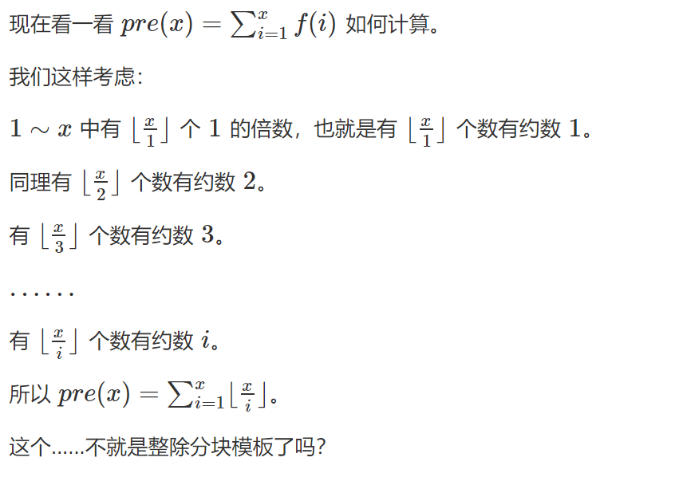

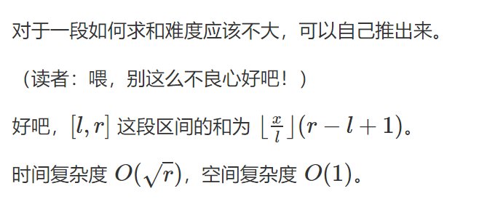

#include<bits/stdc++.h>

using namespace std;

#define ll long long

#define mod 998244353

int main()

{

//freopen("input.txt","r",stdin);

ll x,y;

cin>>x>>y;

//先算pre(y)

ll l,r;

ll ans=0;

for(l=1;l<=y;l=r+1)

{

r=min(y/(y/l),y);

ans=(ans%mod+(y/l)\*(r-l+1)%mod)%mod;

}

//再算pre(x-1)

x--;

for(l=1;l<=x;l=r+1)

{

r=min(x/(x/l),x);

ans=(ans%mod-(x/l)\*(r-l+1)%mod+mod)%mod;

}

cout<<ans%mod<<endl;

return 0;

}